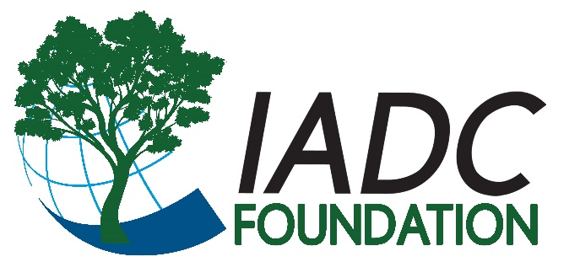
Fundraiser Cookbook
Recipe Submission Form

All submissions due to Mary Beth Kurzak (mkurzak@iadclaw.org).
Please indicate recipe category: Appetizers and hors d’oeuvres Soups and salads
Vegetables, pastas and side dishes Main course Breads/rolls Desserts Beverages
Please indicate difficulty level: Easy Intermediate Advanced
Recipe Title:
Submitted By (Please provide name and location):
Attribution:
Is this recipe adapted from or inspired by a previously published recipe? Yes No
If yes, what publication?
The actual recipe ingredients can be published from the original source as is. Do not include any creative commentary or photos offered by the original author.
Background (If there is a special story/background to this recipe, please provide. We may publish it along with the recipe. Please keep this paragraph to 100 words or fewer.):

Ingredients: (Note as a list. Please reference guidelines when writing.)

Directions: (Provide in paragraph or bulleted list form. Please reference guidelines when writing.)
.

Photo(s): If you have a photo of the finished recipe, a photo of you or your family making it, or a photo related to the special memories that go along with the recipe, please include. Photos submitted with the recipe may be used in the recipe book or in electronic marketing efforts through social media, emails or website. If there are people in the photo, please include their names as they should be listed in the book if the photo is used in the publication. Please provide as high a resolution photo as possible.
- By checking this box, I agree that this recipe can be published, along with any background information and photos provided with it, in the IADC Foundation Cookbook and related marketing.

